Abe Moore Odell
June 2025

C2D2 Tutorial Worksheet

Introduction:
Causally Constrained Decision Dilemmas (C2D2) are decision problems in time limited environments. By harnessing the power of Bayesian Networks and Causal reasoning, we can infer information about the environment and measure the impact of our actions before we take them. Unlike traditional machine learning methods, which are limited to being purely associational, causally informed artificial intelligence introduces tier-2 and tier-3 reasoning (pictured below). This worksheet is designed to introduce the necessary topics for contributing to the C2D2 research space including Bayesian Networks (BNs), how BNs evolve into Causal Decision Networks (CDNs), and Expectimax search.
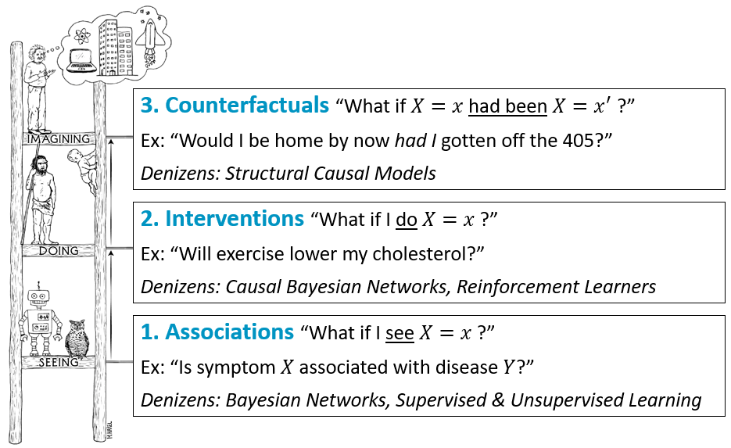

Terms:
Bayesian Network (BN): graphs of state variables connected by cause-and-effect
Causal Decision Networks (CDN): BNs that also include possible actions, and a utility variable
Expectimax Search (ES): a causally informed variant of expectimax search that measures the impact of action choices
Conditional Probability Table (CPT/CPD): a table of state node probabilities given the value of that node’s parents.
Investigations: actions that reveal the current value of a state node.
Interventions: actions that set a state node to a specified value. The likelihood of all descendants of that node then need to be updated to reflect the newly set value.
Hidden State: the true value of each environment variable, which we often don’t know at the beginning of a simulation or search.

More detailed notes and examples can be found here:
https://forns.lmu.build/classes/spring-2024/cmsi-4320/cmsi-4320.html

Bayesian Networks:
Detailed notes: https://forns.lmu.build/classes/fall-2024/cmsi-3300/lecture-3-2.html

Bayesian Networks are a way of representing the environment (the world around us) as a directed, acyclic (no cycles of edge arrows), graph of state variables connected via cause-and-effect edges. Each state node holds the information for one environment variable such as the wind direction, temperature, or if a door is opened or closed. This information is represented by a Conditional Probability Table (CPT), also called a CPD by the library pgmpy in the code.

Here is a simple Bayesian Network modeling if someone is likely in their home and if the lights are on or if there is noise coming from the house:
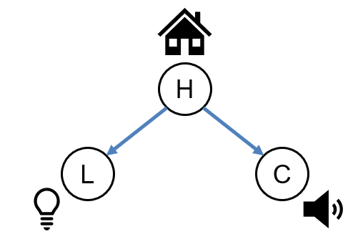
H: whether or not someone is home [0, 1]
L: whether or not the light is on [0, 1]
C: whether or not there is a cacophony in the house [0, 1]

Intuitively, someone being in the house could cause the lights to be on, or for there to be noise. The opposite is not causally true—they could have left the light on after leaving, or maybe they have a dog making noise inside while they are gone. Adding CPTs to our model gives us:

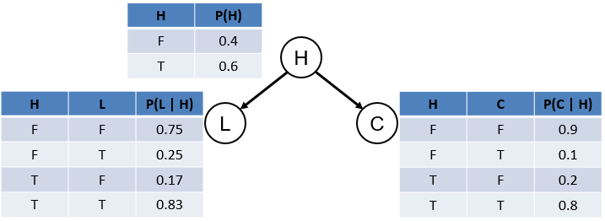

But how did we get these values, and what does P(L|H) mean?
The likelihood of a state variable occurring can be learned from data or given by a subject matter expert. But we can also calculate the likelihood of a child node, given the information about its parents. This is the conditional probability of the node. In other words, what is the likelihood of this node value, given some information about the parent? This is computed using the conditioning rule.
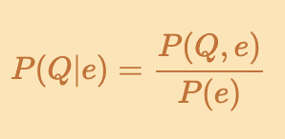
Q: query variable
e: evidence

Practice problems: https://www.khanacademy.org/math/ap-statistics/probability-ap/stats-conditional-probability/e/calculating-conditional-probability

Causal Decision Networks:
Detailed notes: https://forns.lmu.build/classes/fall-2024/cmsi-3300/lecture-5-1.html

Causal Decision Networks (CDNs) are an evolution of Bayesian Networks that also include actions and one or more utility nodes. Actions are ways that we can investigate (learn about) the current state of the network or intervene upon (change) certain node’s values in the network. Possible investigations are represented by triangles, and possible interventions are represented by squares. The current state is also scored by a utility function, represented by a diamond-shaped utility node, the parents of which are the values we are scoring.

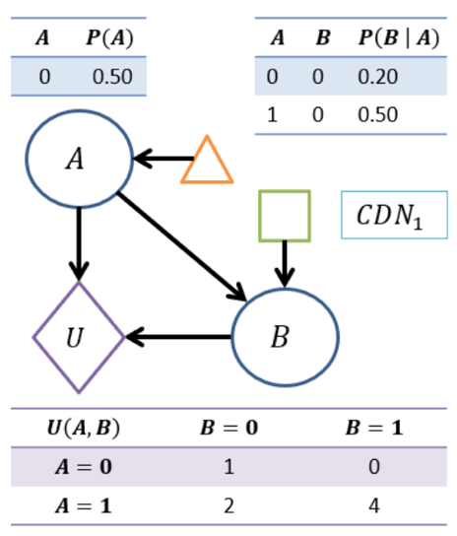

Why are there only half of the rows in the CPTs?
We only need to show half the values for binary variables, because the other rows can be inferred! E.g. if there is a 0.5 chance that A is 0, we know that there is also a 1 – 0.5 = 0.5 chance that it is 1.

Investigations: Investigations are simple, they reveal tier-1 (associational) information about the current value of the hidden state.

Interventions: Interventions set a node’s value in the state, this update is then propagated through the rest of the network and must be reflected in our evidence, or understanding, of the state.

Performing an intervention action is complex and a detailed explanation, including examples, can be found in the “Interventions” section of these notes https://forns.lmu.build/classes/spring-2024/cmsi-4320/lecture-8-1.html

Here is a HW problem from one of Dr. Forney’s classes. It’s hard, so don’t worry if you can’t get it. Luckily, pgmpy has a “do” method, and we have implemented the intervention action already in the GitHub repo. But take some time and think about this problem.
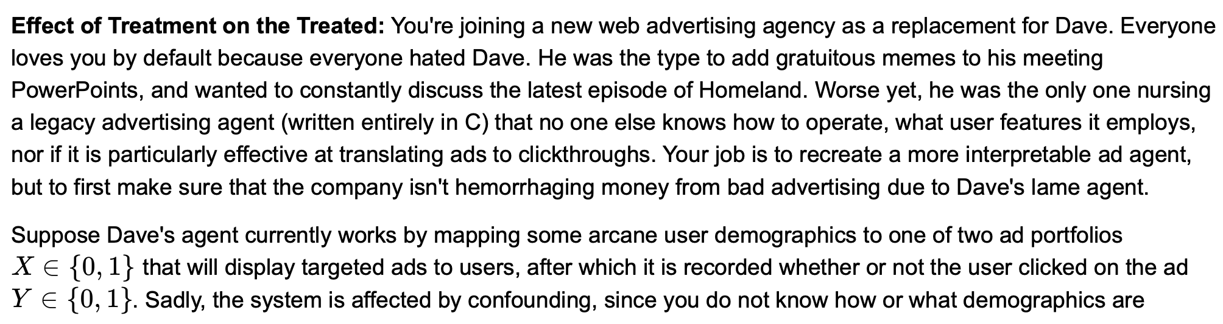
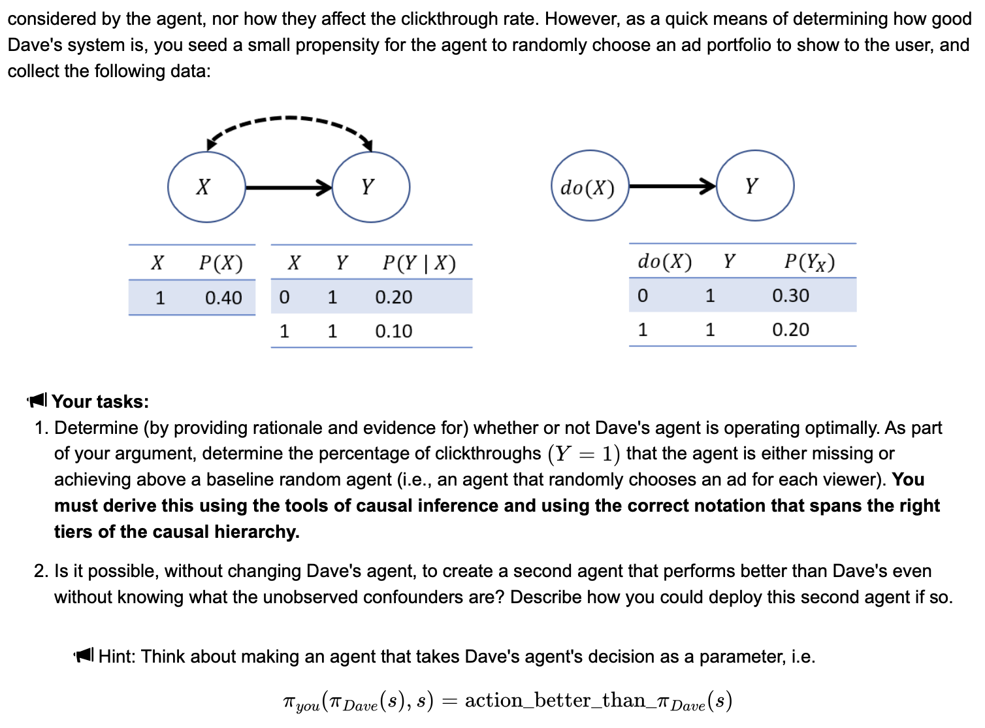

Counterfactuals: Counterfactuals are those “what if?” questions from the third tier of the causal reasoning hierarchy pictured on the first page. Our work utilizes counterfactual reasoning through PCC (pseudo-counterfactual effect) in our Expectimax code, particularly in the _pcc_query method of CDN.

Here are in depth notes on counterfactuals:
https://forns.lmu.build/classes/spring-2024/cmsi-4320/lecture-12-1.html
https://forns.lmu.build/classes/spring-2024/cmsi-4320/lecture-12-2.html

Here is a practice problem from another of Dr. Forney’s homework assignments.

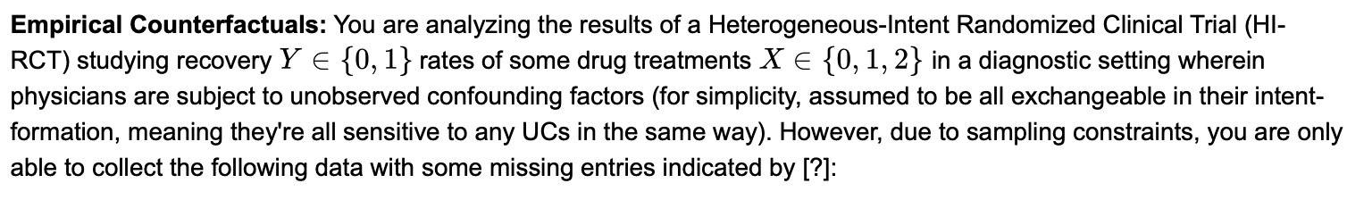
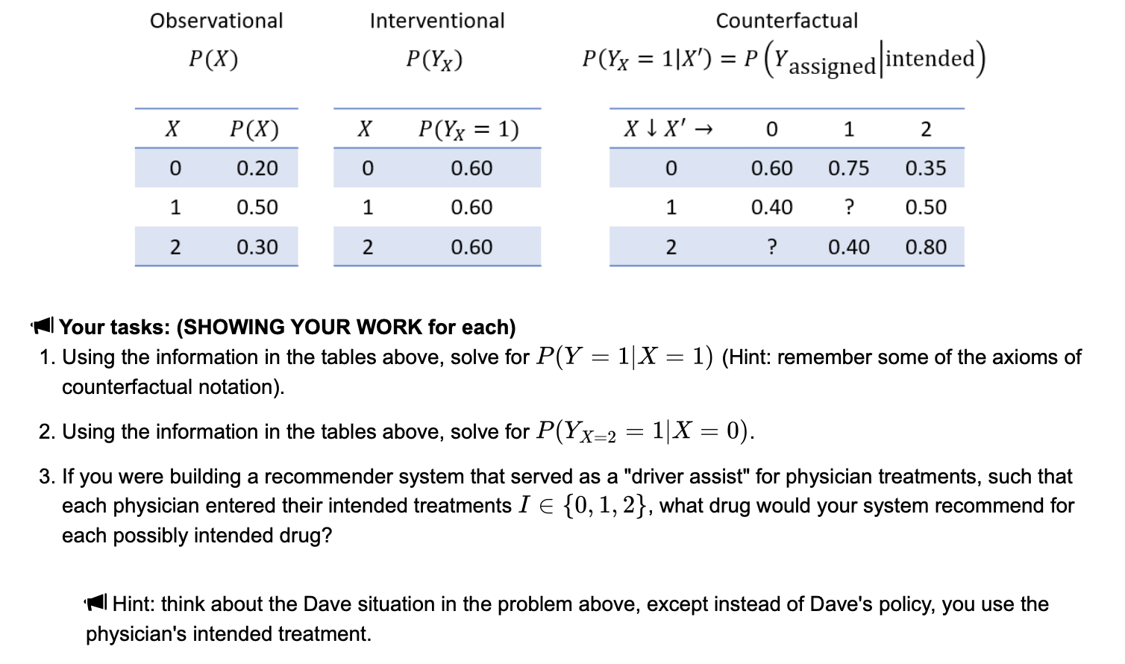

Causal Expectimax Search:
Notes on traditional (non-causal) Expectimax search can be found here: https://www.geeksforgeeks.org/expectimax-algorithm-in-game-theory/
Please read these notes and familiarize yourself with Expectimax before continuing.

Like traditional Expectimax, CES consists of alternating layers of max nodes and chance nodes (also called Q-nodes). Max nodes are represented by triangles, and q-nodes are represented by circles. Terminal state leaf nodes are represented by squares and are scored by the CDN utility function. Unlike traditional Expectimax search, CES introduces a time limit and the causal effects of actions.

Below is a video I made with a tutorial for Causal Expectimax Search.


https://www.youtube.com/watch?v=XmWxkUykYgc&ab_channel=AbeMooreOdell

Further information, particularly information relevant to the programmatic implementation of the discussed topics can be found in the ARL-starter-code GitHub repository. This repository is private. If you need access, please email your GitHub username and associated email address to amooreod@lion.lmu.edu (only until 6/13/2025) or afterwards Andrew.Forney@lmu.edu. If you have any questions, please email them to amooreod@lion.lmu.edu (only until 6/13/2025) or afterwards Andrew.Forney@lmu.edu

